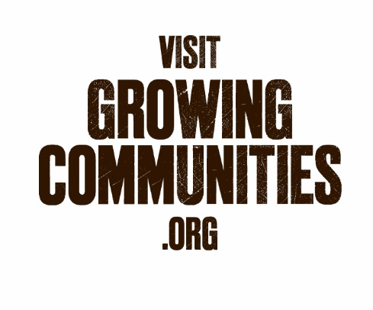

Board elections 2023-24
Growing Communities

Because of Growing Communities' special status as a community business, our members – including veg scheme customers – get to vote for the members of the board and you are also invited to stand for election to the board. There is a nomination form on the next page.
Current board membership

Sarah Havard (Chair)
Richard Dana (Treasurer)
Kath Dalmeny
Geraldine Gilbert
Natalie Silk
Amanda McDonell
Anna Khalfaoui
Clare Hitchcock

Natalie Silk and Richard Dana are retiring ‘by rotation’ this year. Both are seeking re-election.

The other members of the board are not retiring.

The board has spaces for a maximum of 9 members and a minimum of 3.

Personal statement

If you would like to stand for election, we'd like to give you the chance to let other members know a bit about yourself so that they can be better informed in making up their minds if it comes to a vote. So you have the option to supply us with a statement in support of your nomination, of no more than 250 words. We will then circulate this to members with a list of candidates, nearer the AGM.

Return this form to: katy.barker@growingcommunities.org or Katy Barker, Growing Communities, The Old Fire Station, 61 Leswin Road, Stoke Newington, London N16 7NX

NOMINATION FORM

The Rules of the Company state that nominations to the board shall be in writing. Nominees are also encouraged to submit a statement supporting their nomination, of not more than 250 words. The submission of a personal statement is not obligatory, but if there is an election contest, it is likely to be used by members to help them make up their minds. The personal statement may accompany the form or be submitted by email by noon on Monday 8th January 2024 to Katy Barker katy.barker@growingcommunities.org . The personal statement will be circulated to members.

Nominations must be received no later than noon on Monday 8th January 2024.

1. Nominee

To be completed by the nominee:

I, ……..…………………………………………………., am willing to be nominated and elected to the Board of Growing Communities.

Address: ……….……………………………………………………………………………………………………………………………………………………………….

Tel no: . ……………………………………………………..…. Email address………………………….………………………………………………………..

Occupation_____________________________________________________________________

Date of birth…………………………………………

Signed:. ……………………………………………..…………… Date: ………..……………………………………

2. Voting Member

Nomination forms must be signed by a person who is a voting member of Growing Communities (see note). Please either tick the box to confirm that the nominee is a voting member, or ensure the form is countersigned by a voting member who supports the nomination.

o I am a voting member of Growing Communities.

o This form is countersigned below by a voting member of Growing Communities.

Counter signature ……………..…………………………………………………………………………………...

Date ………………………………..………………………...…………………………….................................

Name ………………………………………………………………….…………………………………………….......

3. Personal statement

o A personal statement is being submitted with this form.
o A personal statement will be submitted by email.
o I am not submitting a personal statement.

Note: A voting member is someone who, at midday on 6 December 2023 is a voting member of Growing Communities. A voting member is: a member of the weekly organic fruit and veg scheme, a community member or an honorary member. For more details, please contact Growing Communities.

